Ten A Term –Autumn 2024
Suggested Reads for Year 6
 | Title | Author
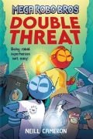 | Mega Robot Bros : Double Threat | Neil Cameron
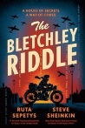 | The Bletchley Riddle | Ruta Sepetys
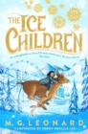 | The Ice Children | M.G. Leonard
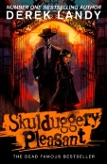 | Skullduggery Pleasant | Derek Landy
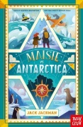 | Maisie VS Antarctica | Jack Jackman
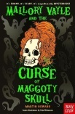 | Mallory Vale :Curse of the Maggoty Skull | Martin Howard
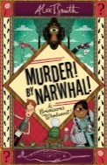 | Murder! By Narwhal! | Alex T. Smith
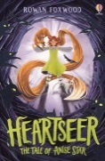 | Heartseer | Rowan Foxwood
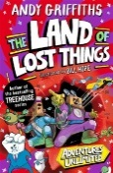 | The Land of Lost Things | Andy Griffiths
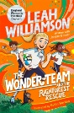 | The Wonder Team and the Rainforest Rescue | Leah Williamson

