 | Nursery | Reception/Year 1 | Year 2 | Year 3 | Year 4 | Year 5 | Year 6
Change Link | What change do you want to make?
Community link | Statham Manor | Cheshire Grange | Keat House | St Mary’s Church | Lymm Methodist Church | Lymm Library | Lymm Heritage Centre
Amazing People assembly links | Nelson Mandela-optimism, Lionel Messi, Jane Goodall- perseverance, Gulwali Passarlay- courage and love, Great Thunberg- integrity and leadership, ELizabeth Wright-optimism
Visits |  | Y1 Halle visit | Halle visit |  |  | Canal visit
Whole school | Summer Fair
English | 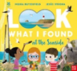    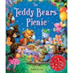 | 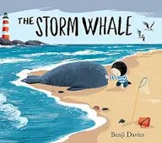  Fiction Outcome:  Friendship story sentences | 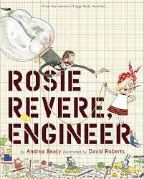 | Manfish by Jennifer Berne  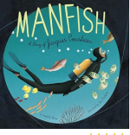  Fiction Outcome:  Invention Narrative  Non-fiction Outcome:  Biography to recount | Manfish by Jennifer Berne  Fiction Outcome:  Invention Narrative  Non-fiction Outcome:  Biography to recount | Shackleton’s Journey  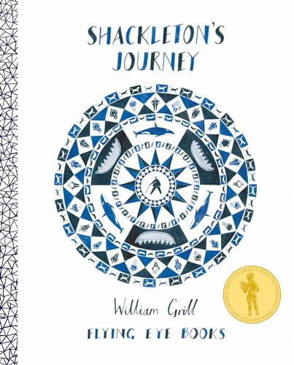 | Shackleton’s Journey
Maths | Unit 9-Find my pattern  Doubling  Sharing/Grouping  Even & Odd  Spatial reasoning 3  Visualise and build  Unit 10-On the move  Deepening understanding  Patterns and relationships  Spatial Mapping  Mapping | Reception: Composition and Comparison  Review and Assess previous units.  YR 1: Mastering Number  Position & Direction  Place Value to 100  Time & Money | Measurement: Time  Measurement:  Mass, Capacity and Temperature | Shape  Mass and Capacity | Decimals B  Money  Time  Shape  Statistics  Position & Direction | Geometry Position and Direction  Measurement – Conversion of Units  Measurement - Volume | Consolidation  Investigations and preparations for KS3
Science | Animals including Humans  Forces  Exploration/Investigation | Materials Part 2 | Animal Life Cycles - Healthy Animals | Plants Artful Flowers, fruits and seed | Living things & their habitats - Conservation | Animals including humans | Second look Science
History | Chronology and Change  Historical Study  Events- traditions | Lymm Through  Time | Changes in Living Memory | Ancient Greece | Normans | Industrial Revolution | Crime and Punishment
Geography |  |  |  | Rio and Brazil | Local Area | European Region Study | Local Area and Region
Computing | Early Digital Music | E Safety  Digital Art | Typing | Comic creation  Music creation | 3D Design  Graphic Design | App Design  Data handling | Computers past, present and future Data Handling  Binary Code  Machine Learning and Intelligence
PSHE | Changing Me
RE |  | Christianity (Church)  EQ-How might some people show that they ‘belong’ to God? | Christianity (Church)  EQ-What unites the Christian community? | Christianity (Church)  What do Christians mean by the ‘Holy Spirit’? | Christianity (Church)  What does ‘love your neighbour’ really mean?  Christianity (Church) | Christianity  (Church)  How do people decide what to  believe | Christianity  (Church) - What do we commit ourselves to on our journey?
Art and Design |  |  |  | 3D/ Sculpture:  Abstract shape and Space |  |  | p
Design Technology | Sculpture and 3D:  Creation station | Food:  Cooking and Nutrition - Smoothies | Mechanisms:  Making a moving monster (4 lessons) |  | Electrical Systems: Torches | Cooking and Nutrition:  Developing a recipe | Digital World:  Navigating the World
French |  |  | Celebrate/  Gingerbreadmen | Food/Where you Live | Body Parts | Going to the Seaside | Performance Time
PE | Golf/Orienteering | Golf/Orienteering | Golf/Orienteering | Golf/Orienteering | Orienteering/  Swimming | Golf/Orienteering | Golf/Orienteering
MUSIC | Sound Stories | High and Low - Exploring Pitch | Patterns with Pitch –  Exploring Pitch and Melody | Violins | Melody Builders - Exploring melody and song structures  Voice Project | Ukulele | Celebrating Songs  Voice Project

