Ten A Term –Summer 2025
Suggested Reads for Year 4
 | Book | Author
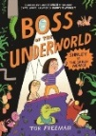 | Boss of the Underworld | Tor Freeman
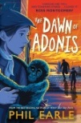 | The Dawn of Adonis | Phil Earle
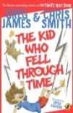 | The Kid Who Fell Through Time | Greg James
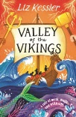 | Valley of the Vikings | Liz Kessler
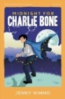 | Midnight for Charlie Bone | Jenny Nimmo
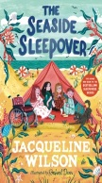 | The Seaside Sleepover | Jacqueline Wilson
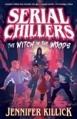 | Serial Chillers | Jennifer Killick
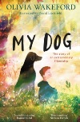 | My Dog | Olivia Wakeford
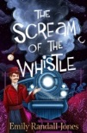 | The Scream of the Whistle | Emily Randall-Jones
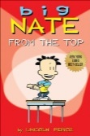 | Big Nate : From the Top | Lincoln Peirce

