Ten A Term –Summer 2025
Recommended Reads for Year 3
 | Title | Author
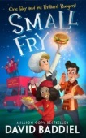 | Small Fry | David Baddiel
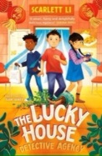 | The Lucky House | Scarlett Li
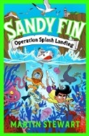 | Sandy Fin: Operation Splash Landing | Martin Stewart
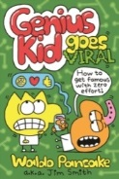 | Genius Kid Goes Viral | Wondo Pancake
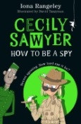 | Cecily Sawyer :How To Be a Spy | Iona Rageley
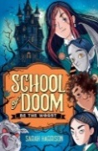 | School of Doom | Sarah Harrison
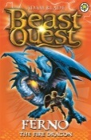 | Ferno the Fire Dragon | Adam Blade
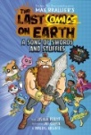 | The Last Comics on Earth | Max Brailler
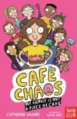 | Café Chaos | Catherine Wilkins
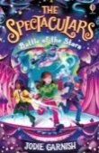 | The Spectaculars : Battle of the Stars | Jodie Garnish

