Ten A Term –Summer 2025
Suggested Non-Fiction – Year 2
 | Title | Author
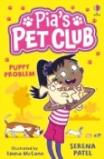 | Pia’s Pet Club | Serena Patel
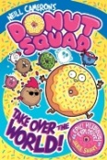 | Donut Squad | Neil Cameron
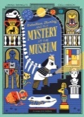 | Detective Stanley and the Mystery of the Museum | Hannah Tunnicliffe
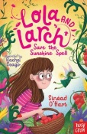 | Lola and Larch Save the Sunshine Spell | Sinead O’Hart
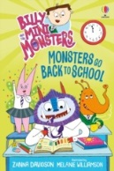 | Monsters Go Back to School | Zanna Davidson
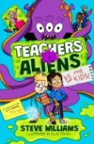 | Teachers vs Aliens | Steve Williams
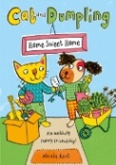 | Cat and Dumpling | Nicola Kent
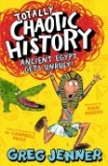 | Ancient Egypt Gets Unruly | Greg Jenner
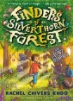 | Finders of Silverthorn Forest | Rachel Chilvers Khoo
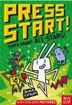 | Super Rabbit All - Stars | Thomas Flintham

