Ten A Term –Summer 2025
Suggested Reads For Year 1
 | Title | Author
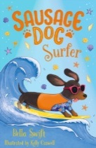 | Sausage Dog Surfer | Bella Swift
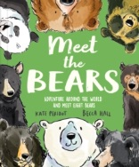 | Meet the Bears | Kate Peridot
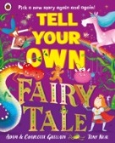 | Tell Your Own Fairy Tales | Adam Guillain
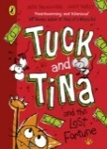 | Tuck and Tina | Jess Brailler
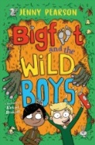 | Bigfoot and the Wild Boys | Jenny Pearson
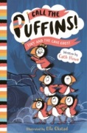 | Call the Puffins: Tiny and the Cave Ghost | Cath Howe
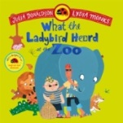 | What the Ladybird Heard | Julia Donaldson
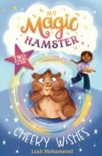 | My Magic Hamster | Leah Mohammed
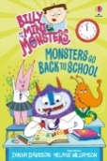 | Monsters Go Back the School | Zanna Davidson
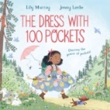 | The Dress With a 100 Pockets | Lily Murray

