Ten A Term – Summer 2025
Suggested Reads for Reception

 | Title | Author
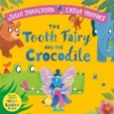 | The Tooth Fairy and the Crocodile | Julia Donaldson
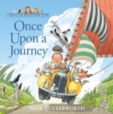 | Once Upon a Journey | Nik Butterworth
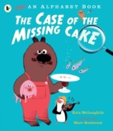 | The Case of the Missing Cake | Eoin McLaughlin
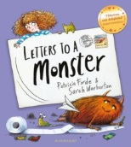 | Letters to a Monster | Patricia Forde
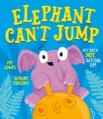 | Elephants Can’t Jump | Pip Jones
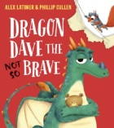 | Dragon Dave the (Not So ) Brave | Alex Latimer
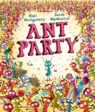 | Ant Party | Ross Montgomery
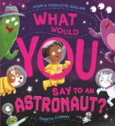 | What Would You Say to an Astronaut? | Adam Guillain
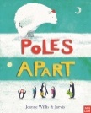 | Poles Apart | Jeanne Willis
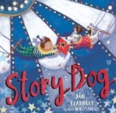 | Story Dog | Jan Fearnley

