Ten A Term – Summer 2025
Suggested Reads for Nursery

 | Title | Author
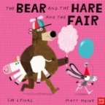 | The Bear and the Hare and the Fair | Em Lynas
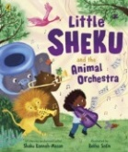 | Little Sheku and the Animal Orchestra | Sheku Kennah-Mason
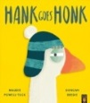 | Hank Goes Honk | Maudie Powell –Tuk
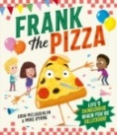 | Frank the Pizza | Eoin Mc Laughlin
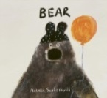 | Bear | Natalia Shaloshvili
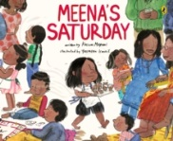 | Meena’s Saturday | Kusum Kipani
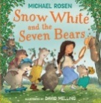 | Snow White and the Seven Bears | Michael Rosen
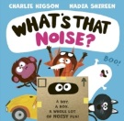 | What’s the Noise? | Charlie Higson
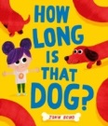 | How Long is that Dog? | John Long
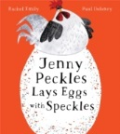 | Jenny Peckles Lays Eggs with Speckles | Rachel Emily

